Header Title: #043192

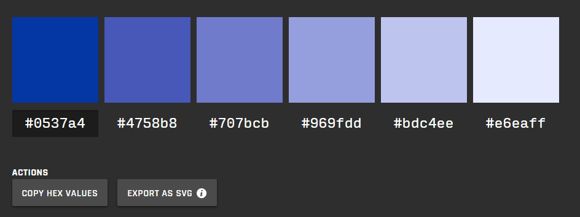

#0537a4 #4758b8 #707bcb #969fdd #bdc4ee #e6eaff